Project Specification - Multiplayer Quiz game app

**Project Title:** MultiplayerQuizApp

**Name:** Matty Christopher (130080943)

**email:** m.e.christopher@se13.qmul.ac.uk / m.christopher@hotmail.co.uk

**project supervisor:** Dr Anne Hsu

**Aim:**

The aim of this project is to create a quiz app for android devices in which users can create questions on their own or as part of groups and to upload them to a database server. The app will allow users to play the quizzes created by themselves and others, each question can be graded on how helpful the questions and answers were to the user. The purpose of the app is to help users revise for upcoming exams or improve their knowledge on certain topics by allowing them to play and create with friends to create another fun way of learning.

**Requirements:**

* The app should allow users to set up a quiz e.g. "Embedded Systems 1" and create a password for editing.
* Users should be able to set up an account which allows the user to keep track of progress and create.
* Users who have a password for a quiz will be able to create a question (either as a group with up to 3 others or on their own). Creating a question will require a user to first create a question e.g. "What is an Interrupt?" and then add the correct answer to one of the four answer slots and place a tick next to the answer. The user can then upload the new question to the database where the users name(username) will be uploaded next to the question. Other users can then find the new question and be able to add an incorrect answer as long as they have the password to the quiz. Once all the answer slots are filled in a user can then submit the final question as ready.
* The app will then allow anyone to play a quiz once at least 5 questions have been submitted for it. The user will have a choice to do all of the questions, attempt the 5 most recent,5 best scored,5 lowest scoring questions or 5 highest scoring.
* After each question the app will display whether the user got it right or not, the database will keep a counter on each question which is updated when a user attempts the question and then whether they got it right. (Question 1 of Embedded Systems 1 has been successfully answered 5/10 times).
* Users will be able to rate each question once answered out of 10.
* The question will also display the username's of the user who created the question and users who created the incorrect answers once the question has been answered.
* The app will also allow users to attempt to get a high score by choosing the mode in which the app will generate an ongoing quiz choosing random questions from all user created quizzes which ends when they get an incorrect answer, the last correct question number will be saved to the users account (unless they already have a score which is higher).
* The app will have a leader board which can be viewed showing all users and rank them by their high score.
* There will be an option if the user has forgotten their username/password to request them via email which the user must enter when creating an account.
* The app will also save the username and password of the last logged in user on their device so they don’t have to keep entering every time.

**Work plan:**

**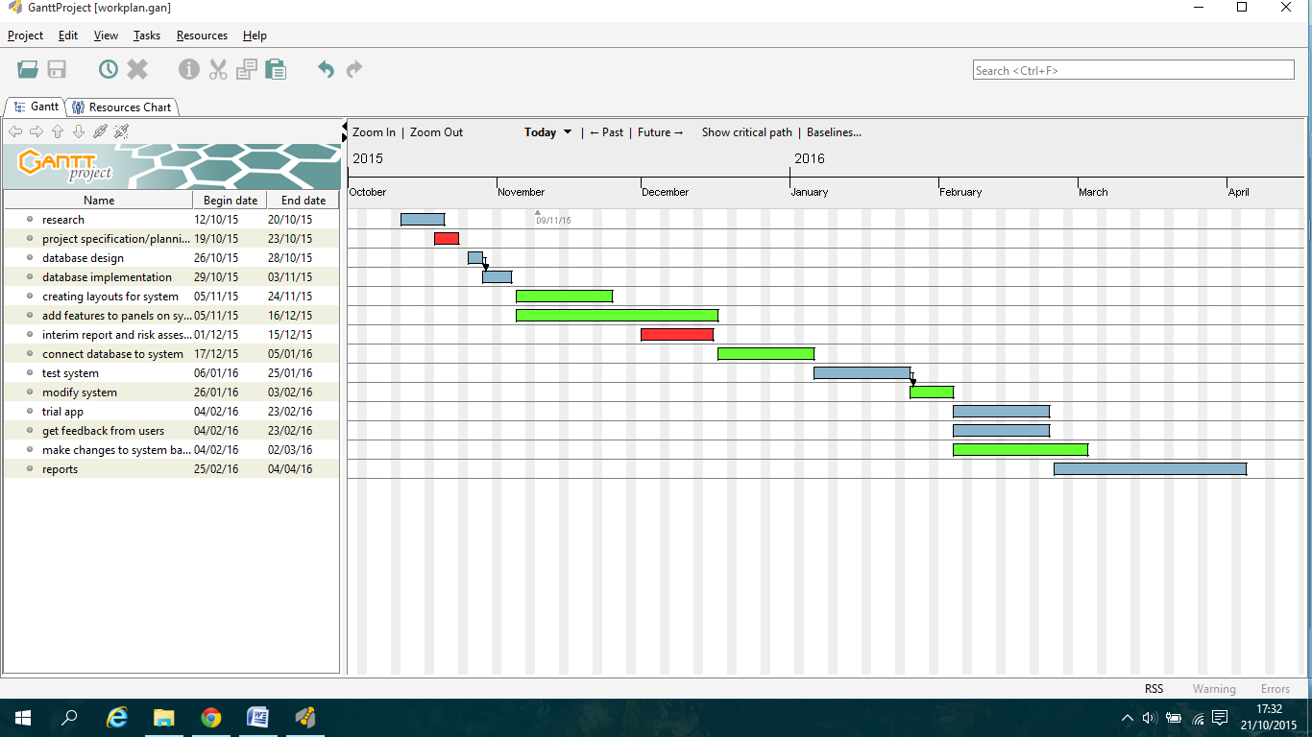**

**Software to be used:**

The app will be created for android in which I will use Android Studio IDE. This uses java and has an emulator in which you can test software easily.

MySQL will be used to create the database which will then be connected to the app to retrieve and upload.

Adobe Fireworks will be used for creating graphics and editing images for the app.

Microsoft Word will be used for any documents that are needed to be written such as reports.

I will use inmotionhosting.com web host to host files and databases.

**Layout and interaction:**

|  |  |
| --- | --- |
| **C:\Users\Matty\Downloads\school\project\planning\layout\login.fw.png** | The user will first see this welcome panel which will have two buttons in which they can press. They can be pressed by using a finger to tap the screen where the buttons are located. If the user presses the **login** button then two text fields one for username and one for password will appear with a button to submit.  If the user has already logged in before then their details will already be filled in. A message will appear if either the username or password is incorrect and a button to request login details will appear where the user can enter their email address.  If the **create account** button is pressed then a series of text fields will appear asking for a username, password and email address. The app will check whether the email address or usernames are already in use and prevent the user from creating an account if either are already in use. |
| **C:\Users\Matty\Downloads\school\project\planning\layout\homepage.fw.png** | When the user successfully logs in they will see this panel. There will be 3 buttons(create, play and leader board). |
| **C:\Users\Matty\Downloads\school\project\planning\layout\create_1.fw.png** | If the user presses the create button then this create panel will appear in which the user can add a question to an existing quiz or if the quiz name doesn’t exist it will create a new quiz with that question. If the quiz already exists then the question will simply be added onto the database containing all the questions relating to that specific quiz. The question name doesn’t have to be the question, but if there is already a question for the quiz with the same name then a message will appear saying to change the question name before they can submit. |
| **C:\Users\Matty\Downloads\school\project\planning\layout\create_2.fw.png** | When the submit button is successfully pressed then this panel will appear in which the user can enter a the question e.g. "2+2=" and then fill in the answers. The correct answer will require the user to tick a radio button at the side next to the correct answer.  If the question already has some of it filled in by another user/s then the filled in boxes will be greyed out so the user cant edit them unless they are the user that created that question or answer/s.  When the submit button is pressed all fields which arent greyed out and have text in them will be recorded with the username of the creator next to them.  e.g. in the database:   |  |  | | --- | --- | | **Answer1:** | **Username a1:** | | 5 | Matty100 | |
| **C:\Users\Matty\Downloads\school\project\planning\layout\play_0.fw.png** | If the user presses the play button on the home panel then this panel will appear with 2 buttons: one for the high score game and another for normal mode in which the user can choose a quiz and how many questions etc they want to do.  The high score game will choose random questions from different quizzes and keep score of each correct answer until the user gets one wrong in which the game will end. |
| **C:\Users\Matty\Downloads\school\project\planning\layout\play_1.fw.png** | If the user chooses the normal mode then a panel with a table will appear.  The table will have a list of all the available quizzes with information about them such as username of the quiz creator, how many questions there are and the average score of each question in the quiz.  The user can slide up or down with their finger to browse the quizzes, to select one they tap on the row they want and then press play. |
| **C:\Users\Matty\Downloads\school\project\planning\layout\play_2.fw.png** | When a quiz is being played the questions will be displayed on this panel which retrieves the info for each field. The answers will be displayed on buttons which when pressed will change colour to indicate that the answer is selected. If the user tries to select another answer when they have already selected one then the old selection will be become unset.  When the user has selected an answer they can press submit.(if the user doesn’t select an answer then when the user presses submit a pop up message will appear telling the user to select an answer).  The rating at the top tells the user how well this question has been scored by other players out of ten, so the higher the score the better. For example the rating will be shown with the total possible score next to it e.g.  12/20 will be displayed for this question meaning that the question has been attempted twice by 2 other people who have each scored it out of ten so one could have given 10/10 and another 2/10.  The questions will also have an average score shown e.g.: 6/10 indicating both scored it 6/10. |
| **C:\Users\Matty\Downloads\school\project\planning\layout\play_3.fw.png** | When the submit button is successfully pressed the correct answer will turn green and if the user selected a wrong answer then their answer will turn red.  The usernames will also appear next to each answer to show the user who created the question and answers. So they can see if some of their friends were involved in creating this question. |
| **C:\Users\Matty\Downloads\school\project\planning\layout\play_4.fw.png** | When the next button is pressed before moving on a pop up message with a text box will ask the user to rate the question. The text box will only allow values 1-10 to be entered. When the submit button is pressed the next question will appear |